**Advance Excel Assignment 1**

1. **What do you mean by cells in an excel sheet?**

A cell is the intersection of a row and a column—in other words, where a row and column meet. Columns are identified by letters (A, B, C), while rows are identified by numbers (1, 2, 3). Each cell has its own name—or cell address—based on its column and row.

1. **How can you restrict someone from copying a cell from your worksheet?**

In order to protect your worksheet from getting copied, you need to go into Menu bar >Review > Protect sheet > Password. By entering password, you can secure your worksheet from getting copied by others.

1. **How to move or copy the worksheet into another workbook?**

The common way to copy a sheet to another workbook is this:

1. Right click on the tab that you want to copy, and then click **Move or Copy…**
2. In the *Move or Copy* dialog box, do the following:
   * Under *To book*, choose the target file. To place a copy into a new workbook, select *(new book).*
   * Under *Before sheet*, specify where to put the copy.
   * Select the **Create a copy** box.
   * Click *OK*.

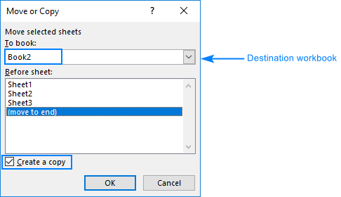

Apart from this traditional route, there is one more way to do the same thing. Guess what, simply by dragging a sheet from one Excel file to another!

1. **Which key is used as a shortcut for opening a new window document?**

Ctrl+N

1. **What are the things that we can notice after opening the Excel interface?**

The interface components of Excel include the Quick Access Toolbar, Ribbon, Name Box, Formula Quick Menu, Formula Bar, Status Bar, Worksheet View Options, Zoom Slider Control, and the Zoom Percentage Indicator.

1. **When to use a relative cell reference in excel?**

Relative references are especially convenient whenever you need to repeat the same calculation across multiple rows or columns.